**MACHINE LEARNING**

**Common Sense**

* When creating a product, always consider the **user** for whom you are making it.
* This includes the **knowledge level** & **interests** of the end user.

**Types of Analysis**

* **Descriptive analysis:** Tells report of **what happened** in a past event.
* **Diagnostic analysis:** Tells report of **why it happened**, or explains certain trends in statistics.
* **Predictive analysis:** Predicts **what might happen** in the future (accuracy may vary).
* **Prescriptive analysis:** **Recommends actions** to improve the statistics as required.

**Famous Tools for Data Visualisation**

* ***Tableau***
* ***Microsoft Power BI***
* ***Microsoft Excel***
* ***Google Data Studio***
* ***Matplotlib***
* ***Looker***

**Excel Data Visualization**

* Primary tools available after: ***Insert*** -> ***Recommend pivot table***
* ***Pivot table analyse*** -> ***Fields, items & sets*** -> ***Calculated fields***

**Matplotlib & Pandas**



* Showing graph



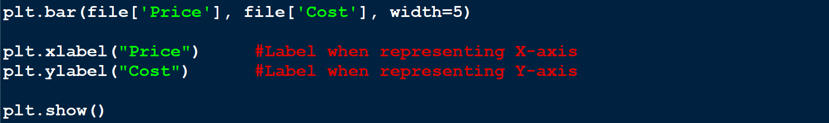

* First **two arguments** in 1st line are **x-axis** & **y-axis**.
* ***bar*** draws **bar graph**, similarly ***pie*** draws **pie chart**.

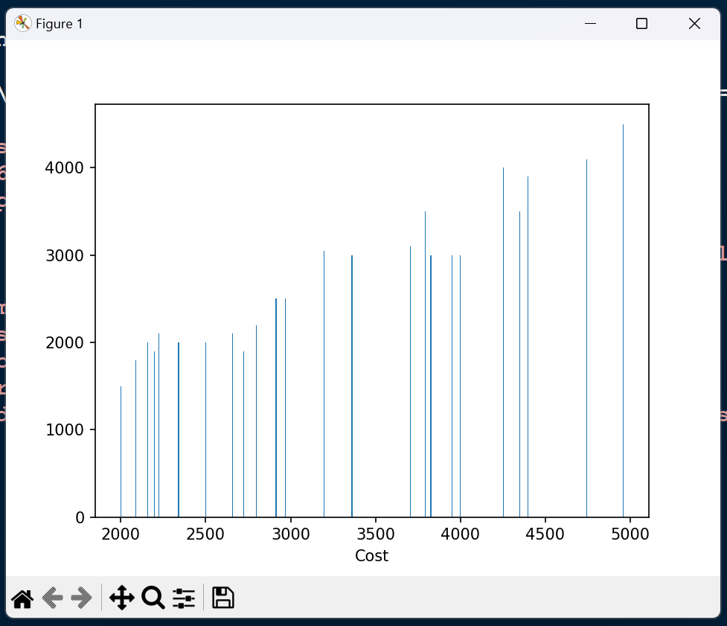

**Regression Model**

* **Regression based prediction:** Done through observing past records of that data.
* **Outlier:** Ignoring data in record showing **large variation**, in order to avoid wrong impression of record (data integrity).

**Simple Linear Regression**

* **Two variables** are involved in the equation.
* **One variable** is dependent, and another one is independent.
* **For example:**

**y = x – 3**

**=> Profit = MRP – 3**

**Here, *y* is dependent whereas *x* is independent.**

* We draw the **least error giving line** from each value in the graph.
* We use **line’s equation**:

**y = mx + c OR y = a + bx**

* This helps us **predicting** the next outcome.

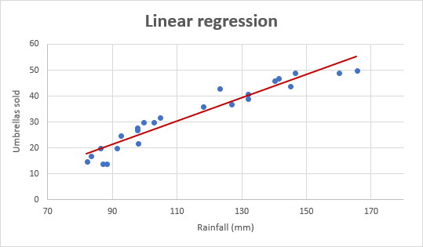

* For drawing it on **graph**, just **change** ***.bar*** line to:



* To draw the **regression line**:



**Multiple Linear Regression**

* Multiple graphs are drawn for separate dependencies among variables.
* **Equation:**

**y = b0x0 + b1x1 + b2x2 + … + bnxn**

**Linear Regression Formula**

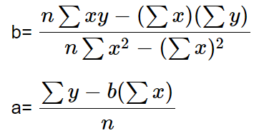

***a* = Y-intercept of line**

***b* = Slope of the line**

**Other Types of Regression Models**

* Logistic regression
* Ordinal regression
* Multinomial regression
* Discriminant analysis